**CURRICULUM-VITAE**

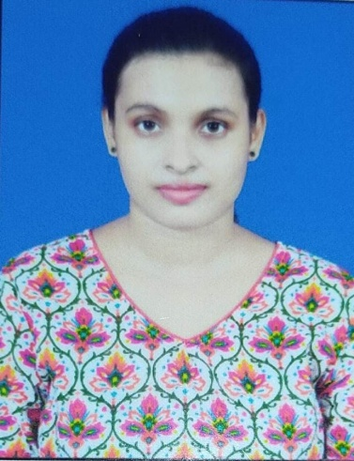

**ASWASANA MOHAPATRA**

C/O- Sukant Kumar Mohapatra

Address :- At- Ghoda Bazar

Near Railay Station

Po- Puri

P.S –Sea Beach

Dist – Puri

Pin – 752002

Phone No:-7064041646/8117016419

Email:-aswasana6789@gmail.com

**CAREER OBJECTIVE:-**

Seeking a responsible and challenging assignment, which allows me to explore my capabilities and skills up to fullest extend resulting in my career growth as well as achievement of organizational goals as well as self goals

**EDUCATIONAL QUALIFICATION:-**

* +3 (Commerce) from S.C.S (A) College, Puri, Utkal University in the year 2019 having 64.95%.
* +2 (Commerce) from CHSE, Odisha in the year 2016 having 61.16%.
* 10th from ICSE Board in the year 2014 having 63.83%.

**EXTRA QUALIFICATION:-**

* PGDCA
* Tally

**EXPERIENCE:-**

* **WORK** Working as a Data Entry Operator at Enhira Software Pvt. Ltd. From last 1year.

**PERSONAL QUALITIES :-**

Always think Positive, hardworking capability, Helpful, Create new friends and faith in God.

**PERSONAL DETAILS:-**

Name : Aswasana Mohapatra

Father’s Name : Sukant Kumar Mohapatra

Date of Birth : 18th Dec 1997

Sex : Female

Marital Status : Unmarried

Nationality : Indian

Religion : Hindu

Language Known : English, Hindi & Odia

Categories : General

Area Of Interest : Reading News Papers & Novels

Cooking

Permanent Address : At- Ghoda Bazar

Near Railay Station

Po- Puri

P.S –Sea Beach

Dist – Puri

Pin – 752002

**DECLARATION**

I do here by declare that all the statements furnished above are true to the best of my knowledge and belief.

Date:- (Aswasana Mohapatra)

Place:-Puri Signature of the Candidate